Ben Brandhorst

CMIS 242

April 14th, 2019

**Project 2  
Automated Teller Machine**

|  |  |  |  |
| --- | --- | --- | --- |
| **INPUT** | **EXPECTED OUTPUT** | **ACTUAL OUTPUT** | **PASS??** |
| **JButton Press:** Withdraw  **JRadioButton Selected:** Checking  **JTextField Entry:** EeeFs | **JOptionPane** “Please enter a value in whole dollar multiples of $20.” | **JOptionPane** “Please enter a value in whole dollar multiples of $20.” | YES |
| **JButton Press:** Withdraw  **JRadioButton Selected:** Checking  **JTextField Entry:** 111 | **JOptionPane** “This ATM only dispenses 20 dollar bills. Pleas enter a withdraw amount in multiples of 20.” | **JOptionPane** “This ATM only dispenses 20  dollar bills. Pleas enter a withdraw amount in multiples of 20.” | YES |
| **JButton Press:** Withdraw  **JRadioButton Selected:** Checking  **JTextField Entry:** 100 | **JOptionPane** “$100.00 withdrawn from Checking. Balance: $900.00” | **JOptionPane** “$100.00 withdrawn from  Checking. Balance: $900.00” | YES |
| **JButton Press:** Withdraw  **JRadioButton Selected:** Checking  **JTextField Entry:** 10000 | **JOptionPane** “Insufficient Funds in Account. Please Try Again” | **JOptionPane** “Insufficient Funds in Account. Please Try Again” | YES |
| **JButton Press:** Withdraw  **JRadioButton Selected:** Savings  **JTextField Entry:** yeaGH | **JOptionPane** “Please enter a value in whole dollar multiples of $20.” | **JOptionPane** “Please enter a value in whole dollar multiples of $20.” | YES |
| **JButton Press:** Withdraw  **JRadioButton Selected:** Savings  **JTextField Entry: 333** | **JOptionPane** “This ATM only dispenses 20 dollar bills. Pleas enter a withdraw amount in multiples of 20.” | **JOptionPane** “This ATM only dispenses 20  dollar bills. Pleas enter a withdraw amount in multiples of 20.” | YES |
| **JButton Press:** Withdraw  **JRadioButton Selected:** Savings  **JTextField Entry:** 60 | **JOptionPane** “$100.00 withdrawn from  Savings. Balance: $900.00” | **JOptionPane** “$100.00 withdrawn from  Savings. Balance: $900.00” | YES |
| **JButton Press:** Withdraw  **JRadioButton Selected:** Savings  **JTextField Entry:** 6000 | **JOptionPane** “Insufficient Funds in Account. Please Try Again” | **JOptionPane** “Insufficient Funds in Account. Please Try Again” | YES |
| **JButton Press:** Deposit  **JRadioButton Selected:** Checking  **JTextField Entry:** ee | **JOptionPane** “Please enter a numeric value” | **JOptionPane** “Please enter a numeric value” | YES |
| **JButton Press:** Deposit  **JRadioButton Selected:** Checking  **JTextField Entry:** 100 | **JOptionPane** “$100.00 deposited to  Checking. Balance: $1100.00” | **JOptionPane** “$100.00 deposited to  Checking. Balance: $1100.00” | YES |
| **JButton Press:** Deposit  **JRadioButton Selected:** Savings  **JTextField Entry:** qaz123 | **JOptionPane** “Please enter a numeric value” | **JOptionPane** “Please enter a numeric value” | YES |
| **JButton Press:** Deposit  **JRadioButton Selected:** Savings  **JTextField Entry:** 200 | **JOptionPane** “$200.00 deposited to  Checking. Balance: $1200.00” | **JOptionPane** “$200.00 deposited to  Checking. Balance: $1200.00” | YES |
| **JButton Press:** Transfer To  **JRadioButton Selected:** Checking  **JTextField Entry:** zzz | **JOptionPane** “Please enter a numeric value” | **JOptionPane** “Please enter a numeric value” | YES |
| **JButton Press:** Transfer To  **JRadioButton Selected:** Checking  **JTextField Entry:** 10000 | **JOptionPane** “Insufficient Funds in Account. Please Try Again” | **JOptionPane** “Insufficient Funds in Account. Please Try Again” | YES |
| **JButton Press:** Transfer To  **JRadioButton Selected:** Checking  **JTextField Entry:** 1000 | **JOptionPane** “Transferred $1000.00 from Savings to Checking. Checking Balance: $2000.00” | **JOptionPane** “Transferred $1000.00 from Savings to Checking. Checking Balance: $2000.00” | YES |
| **JButton Press:** Transfer To  **JRadioButton Selected:** Savings  **JTextField Entry:** xxx | **JOptionPane** “Please enter a numeric value” | **JOptionPane** “Please enter a numeric value” | YES |
| **JButton Press:** Transfer To  **JRadioButton Selected:** Savings  **JTextField Entry:** 9999 | **JOptionPane** “Insufficient Funds in Account. Please Try Again” | **JOptionPane** “Insufficient Funds in Account. Please Try Again” | YES |
| **JButton Press:** Transfer To  **JRadioButton Selected:** Savings  **JTextField Entry:** 100 | **JOptionPane** “Transferred $100.00 from Savings to Checking. Savings Balance: $1100.00” | **JOptionPane** “Transferred $100.00 from Savings to Checking. Savings Balance: $1100.00” | YES |
| **JButton Press:** Balance  **JRadioButton Selected:** Checking  **JTextField Entry:** null | **JOptionPane** “Checking Balance: $1000.00” | **JOptionPane** “Checking Balance: $1000.00” | YES |
| **JButton Press:** Balance  **JRadioButton Selected:** Savings  **JTextField Entry:** null | **JOptionPane** “Savings Balance: $1000.00” | **JOptionPane** “Savings Balance: $1000.00” | YES |

**Test Case 1 Output Example: (Checking: Non numeric Withdraw input)**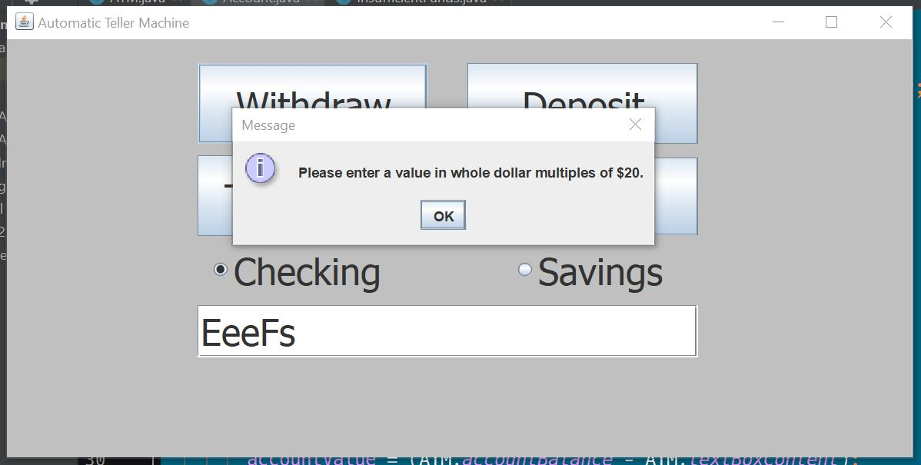

**Test Case 2 Output Example: (Checking: Non multiple of 20 Withdraw input)**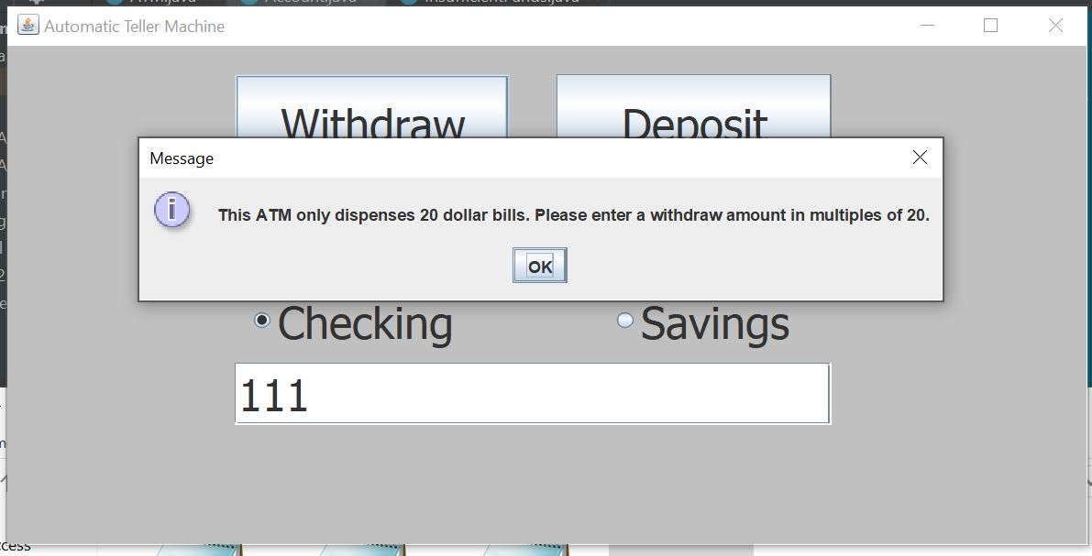

**Test Case 3 Output Example: (Checking: Regular withdraw)**

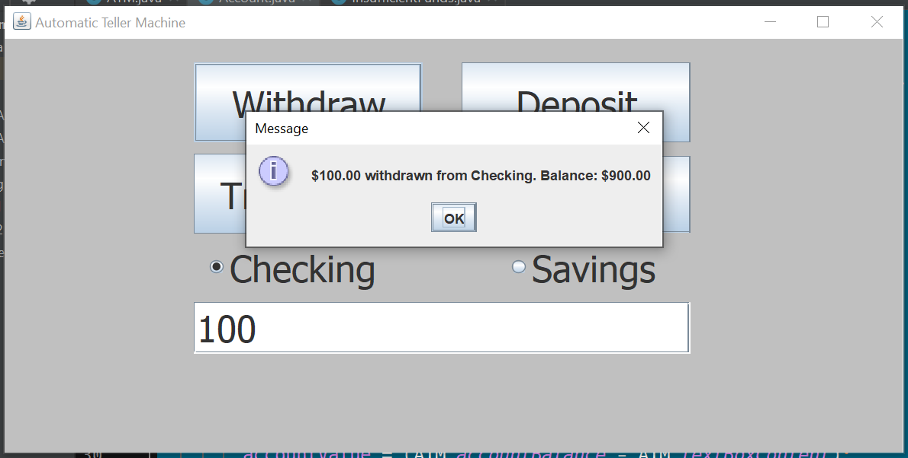

**Test Case 4 Output Example: ( Checking: Overdraw account Withdraw attempt)**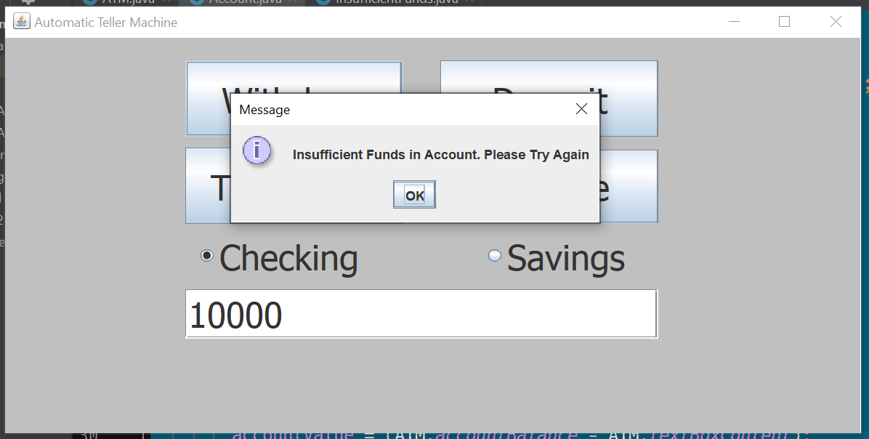

**Test Case 5 Output Example: (Savings: Non numeric Withdraw input)**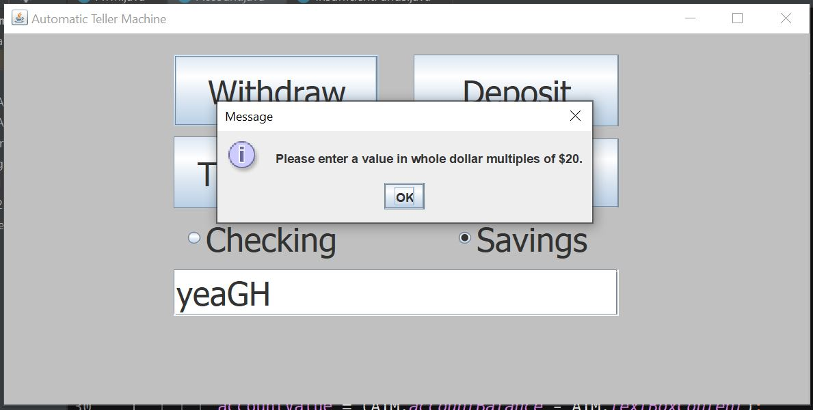

**Test Case 6 Output Example: (Savings: Non multiple of 20 Withdraw input)**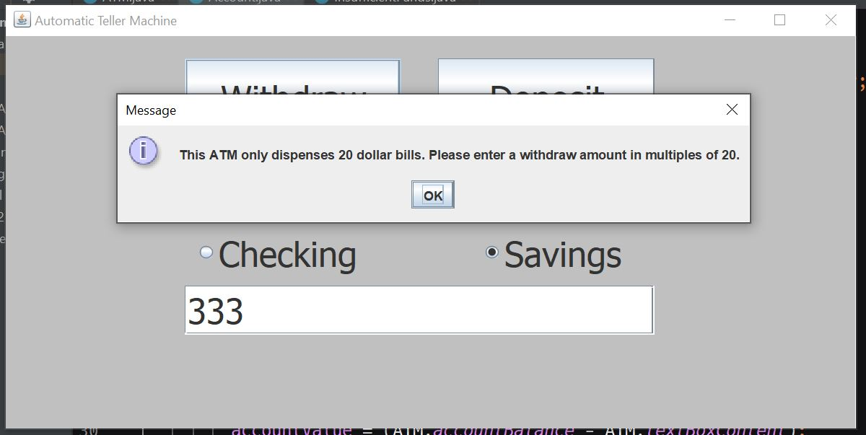

**Test Case 7 Output Example: (Savings: Regular withdraw)**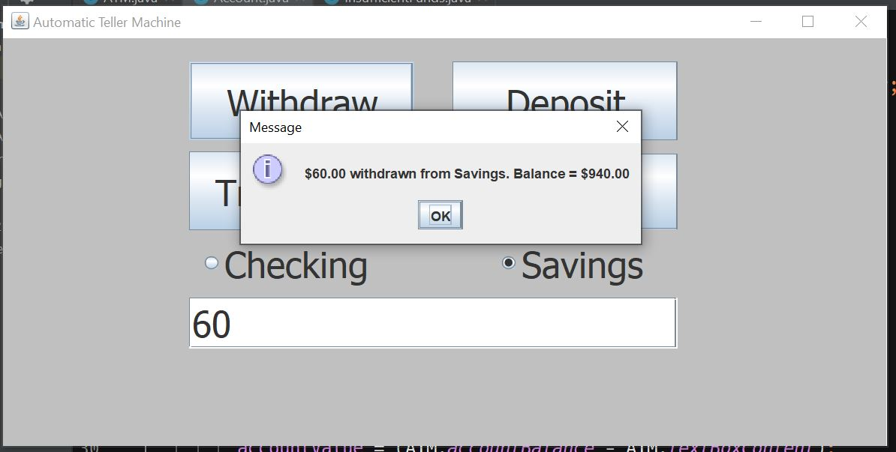

**Test Case 8 Output Example: (Savings: Overdraw account Withdraw attempt)**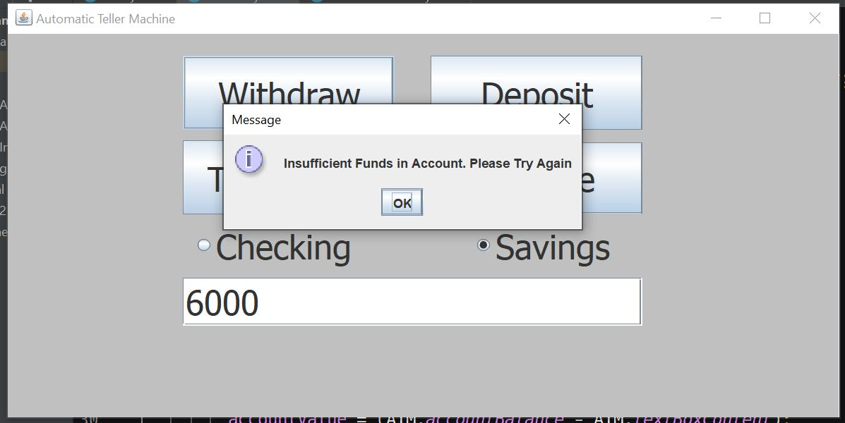

**Test Case 9 Output Example: (Checking: Non numeric deposit attempt)**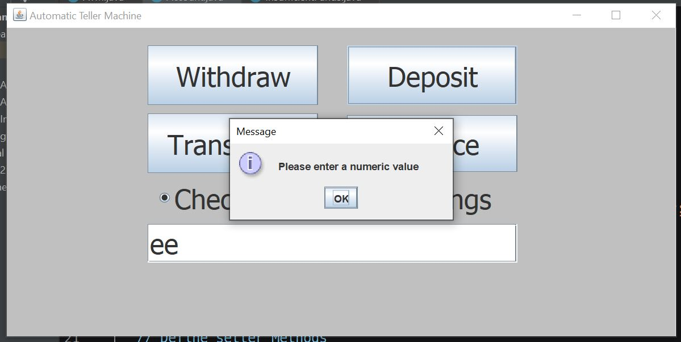

**Test Case 10 Output Example: (Checking: Regular deposit)**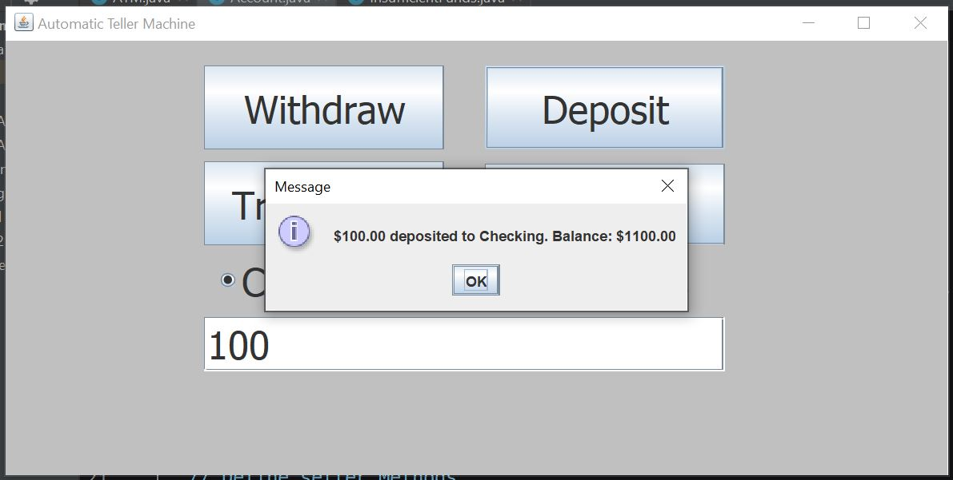

**Test Case 11 Output Example: (Savings: Non numeric Deposit attempt)**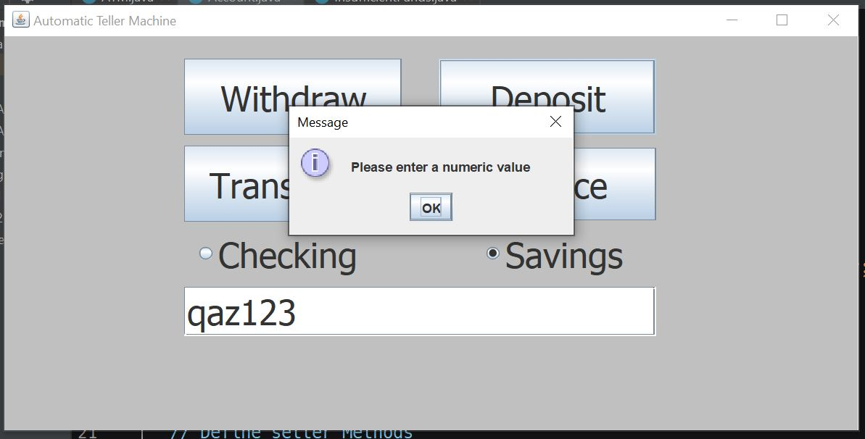

**Test Case 12 Output Example: (Savings: Regular deposit)**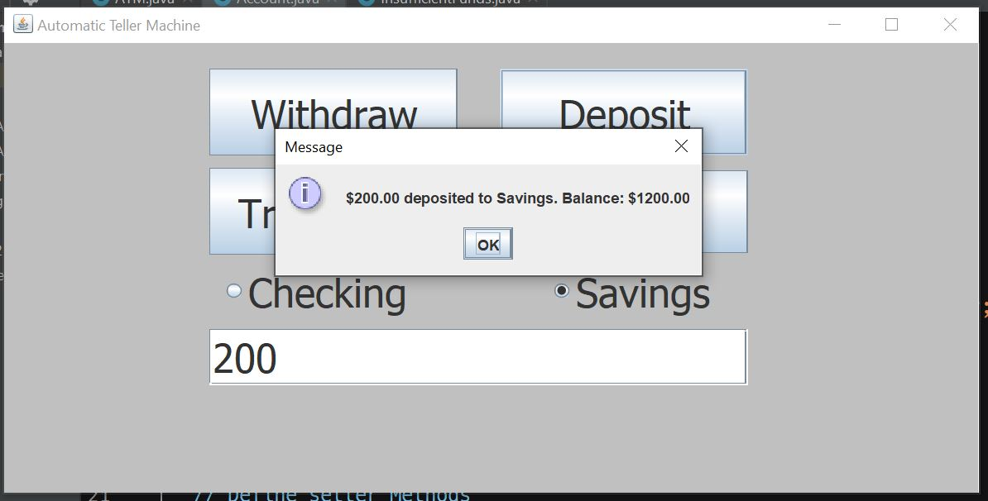

**Test Case 13 Output Example: (Checking: Non numeric Transfer To attempt)**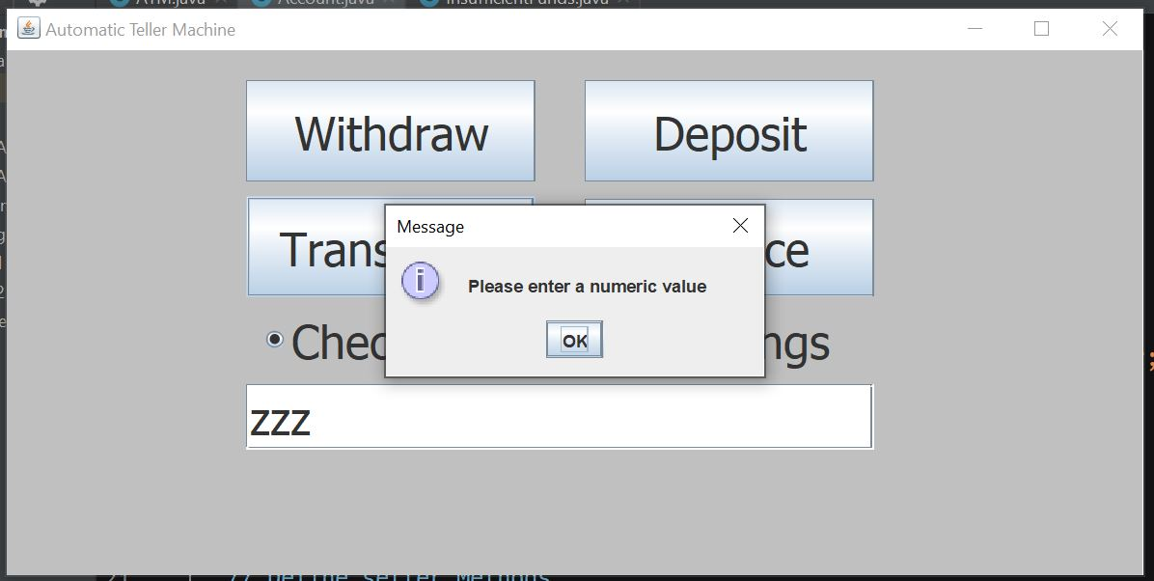

**Test Case 14 Output Example: (Checking: Attempt to transfer too much funds)**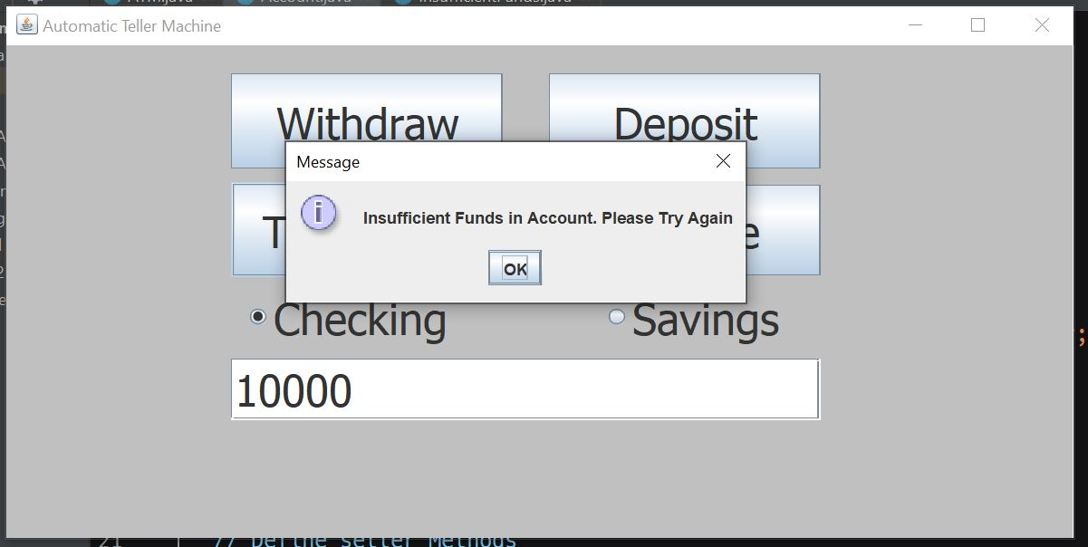

**Test Case 15 Output Example: (Checking: Regular transfer)**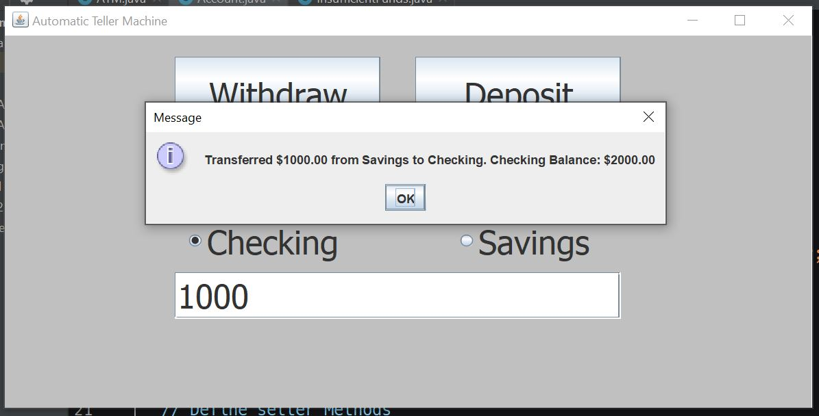

**Test Case 16 Output Example: (Savings: Non numeric transfer attempt)**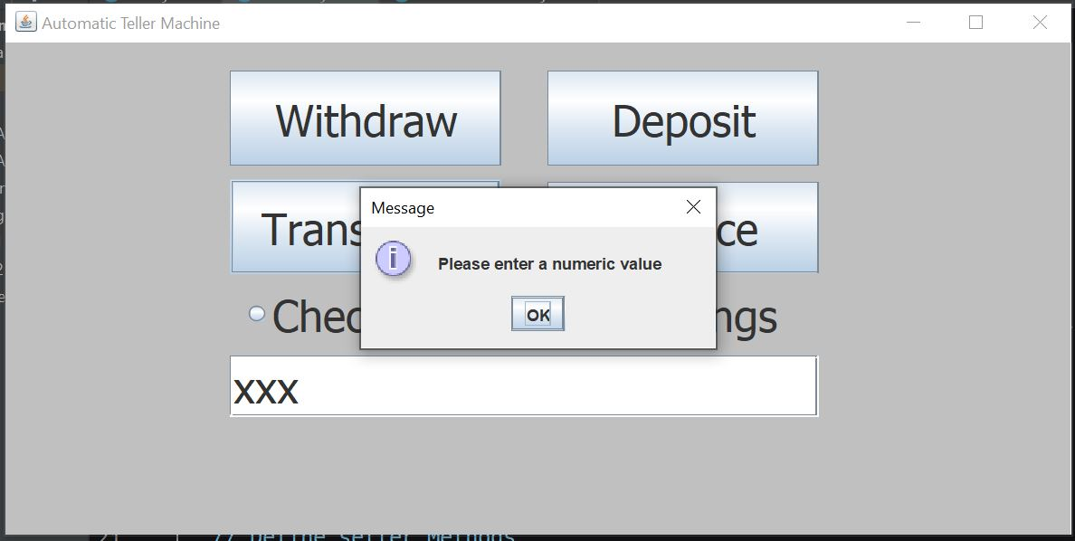

**Test Case 17 Output Example: (Savings: Attempt to transfer too much funds)**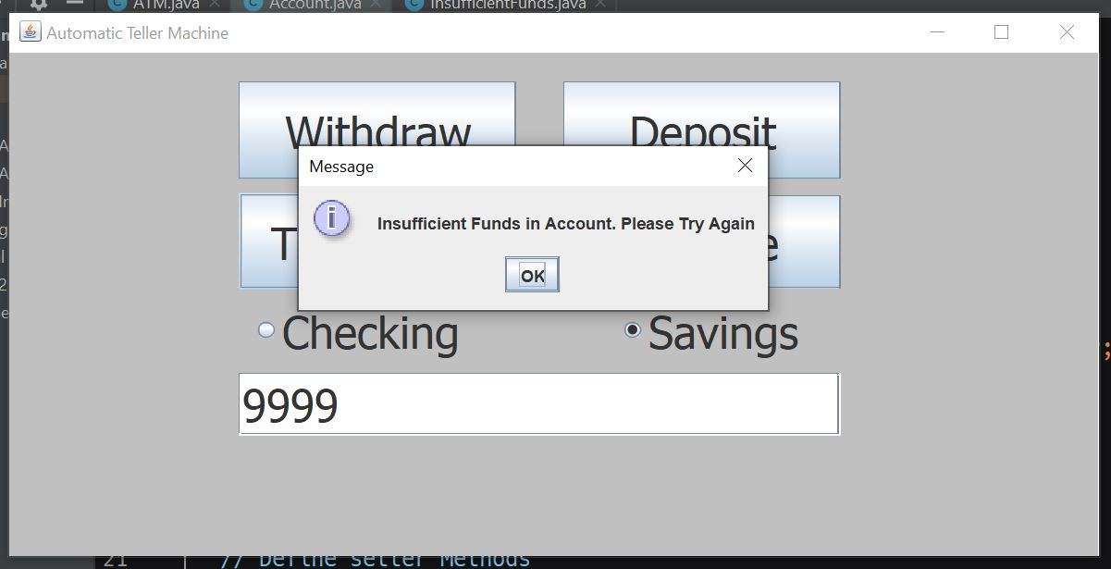

**Test Case 18 Output Example: (Savings: Regular transfer)**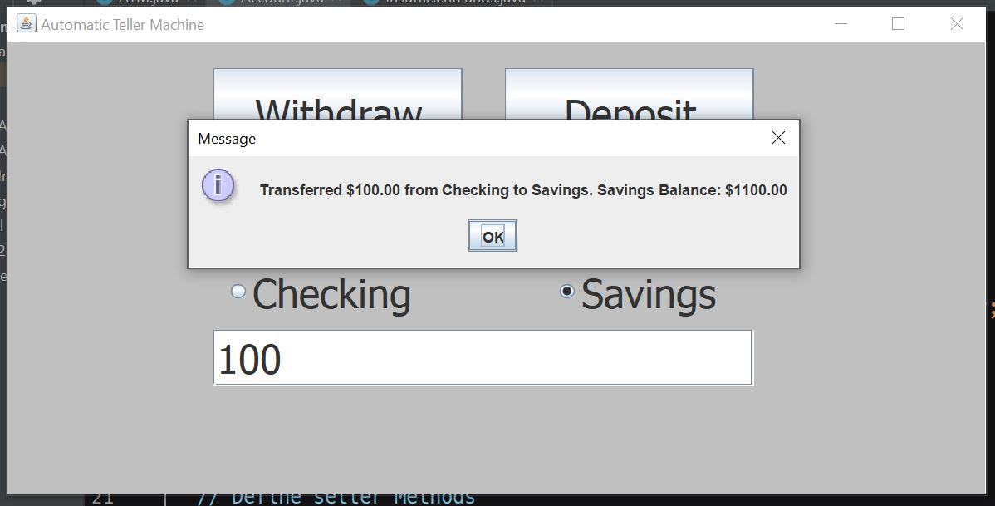

**Test Case 19 Output Example: (Checking: Balance check)**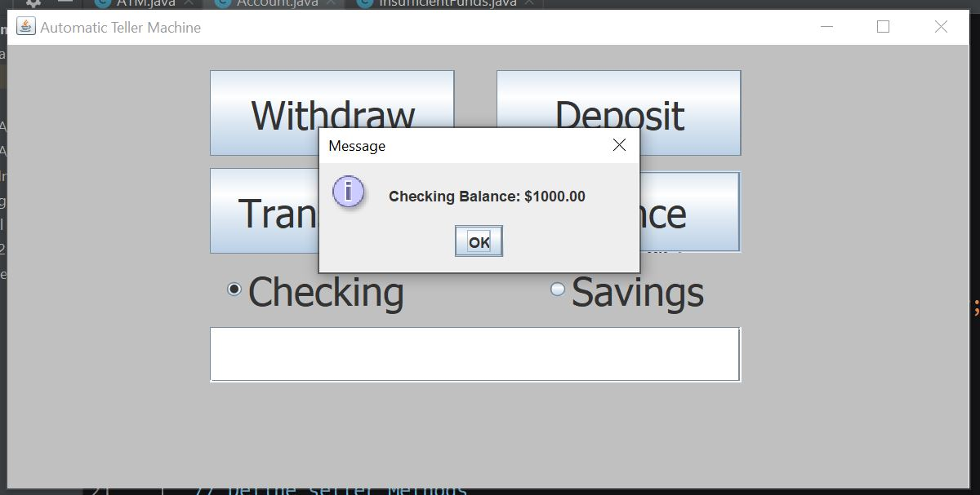

**Test Case 20 Output Example: (Savings: Balance check)**